# First Year Internship

7 July 2022

1. Write a program to check if a given number is Positive, Negative, or Zero.

Input – An integer from the user

Output – Print Positive if number is positive Negative if the number is negative and Zero is number is 0

Algorithm

Ask user to enter an integer.

Store integer value.

If the value entered is greater than 0

Then print that the number is positive

Otherwise, if the value is less than 0

Then print that number is negative

Finally, if both conditions are false then number is 0

Hence print number is zero

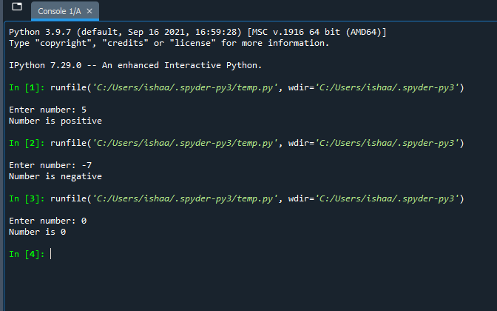**Code (In python)**

num = int(input("Enter number: "))

if num>0:

print("Number is positive")

elif num<0:

print("Number is negative")

else:

print("Number is 0")

2. Write a program to check if a given number is odd or even.

Input – An integer value by the user

Output – Print even if the number is divisible by 2 else print odd.

Algorithm

Ask use to enter integer value

Store the integer

If the number is divisible by 2

Then print number is even

Otherwise,

Print number is Odd

**Code (In python)**

num = int(input("Enter Number: "))

if num%2==0:

print("Nunber is Even")

else:

print("Number is Odd")

3. Write a program to read the values from user and print all the values in a single line separated by ,(comma). Example Mumbai Bangalore O/P: Mumbai,Bangalore

Input –City names with single spaces from user

Output – To print the cities entered separated by commas instead of spaces

Algorithm

Read the entered string with city names separated by single spaces as string

In a loop, iterate through each element of the string

If the element is a blank space print comma

Otherwise print the element as it is

**Code (In python)**

x = input(“Enter City names with spaces: ”)

for i in x:

if i == ‘ ‘:

print(“,” , end = “”)

else:

print(i, end = “”)

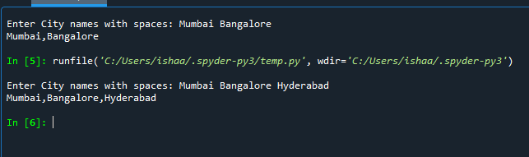

4. Initialize two character variables in a program and display the characters in alphabetical order. Eg1) if first character is s and second is e O/P: e,s Eg2) if first character is a and second is e O/P:a,e

Input – Two characters from user

Output – Characters in ascending order of the alphabet

Algorithm

Ask user for two characters

Compare the two characters

Print the character whose ascii value is lower then the character with higher ascii value.

**Code (In Python)**

ch1 = input("Enter first character: ")

ch2 = input("Enter second character: ")

if ch1>ch2:

print(ch2 + "," + ch1)

else:

print(ch1 + "," + ch2)

